**DESCRIPTIVE STATISTICS USING R PROGRAMMING ALONG WITH THE DEMONSTRATION**

# **Frequency tables**

A frequency table (or contingency table) is used to describe categorical variables. It contains the counts at each combination of factor levels.

R function to generate tables: **table**()

## **Create some data**

Distribution of hair and eye color by sex of 592 students:

**# Hair/eye color data**

**df <- as.data.frame(HairEyeColor)**

**hair_eye_col <- df[rep(row.names(df), df$Freq), 1:3]**

**rownames(hair_eye_col) <- 1:nrow(hair_eye_col)**

**head(hair_eye_col)**

Hair Eye Sex

1 Black Brown Male

2 Black Brown Male

3 Black Brown Male

4 Black Brown Male

5 Black Brown Male

6 Black Brown Male

**# hair/eye variables**

**Hair <- hair_eye_col$Hair**

**Eye <- hair_eye_col$Eye**

## 

## **Simple frequency distribution: one categorical variable**

* Table of counts

# Frequency distribution of hair color

**table(Hair)**

Hair

Black Brown Red Blond

108 286 71 127

# Frequency distribution of eye color

**table(Eye)**

Eye

Brown Blue Hazel Green

220 215 93 64

* Graphics: to create the graphics, we start by converting the table as a data frame.

# Compute table and convert as data frame

**df <- as.data.frame(table(Hair))**

df

Hair Freq

1 Black 108

2 Brown 286

3 Red 71

4 Blond 127

# Visualize using bar plot

**library(ggpubr)**

**ggbarplot(df, x = "Hair", y = "Freq")**

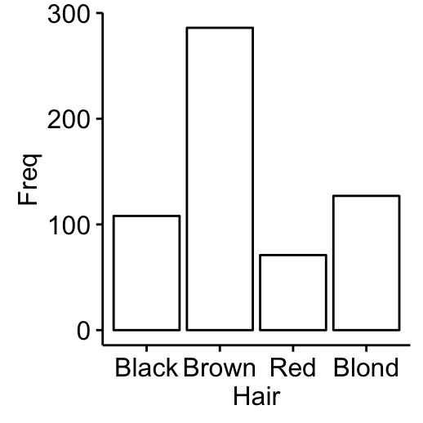

## 

## 

## 

## **Two-way contingency table: Two categorical variables**

**tbl2 <- table(Hair , Eye)**

tbl2

Eye

Hair Brown Blue Hazel Green

Black 68 20 15 5

Brown 119 84 54 29

Red 26 17 14 14

Blond 7 94 10 16

It’s also possible to use the function **xtabs**(), which will create cross tabulation of data frames with a formula interface.

**xtabs(~ Hair + Eye, data = hair_eye_col)**

* Graphics: to create the graphics, we start by converting the table as a data frame.

**df <- as.data.frame(tbl2)**

**head**(df)

Hair Eye Freq

1 Black Brown 68

2 Brown Brown 119

3 Red Brown 26

4 Blond Brown 7

5 Black Blue 20

6 Brown Blue 84

# Visualize using bar plot

**library(ggpubr)**

**ggbarplot(df, x = "Hair", y = "Freq",**

**color = "Eye",**

**palette = c("brown", "blue", "gold", "green"))**

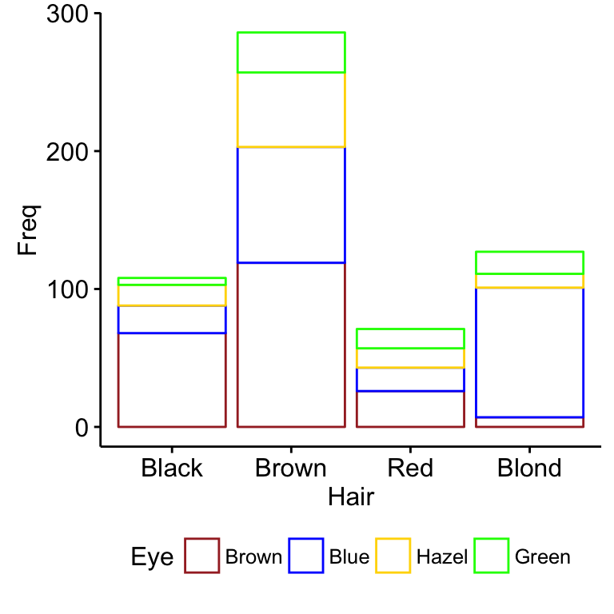

# position dodge

**ggbarplot(df, x = "Hair", y = "Freq",**

**color = "Eye", position = position_dodge(),**

**palette = c("brown", "blue", "gold", "green"))**

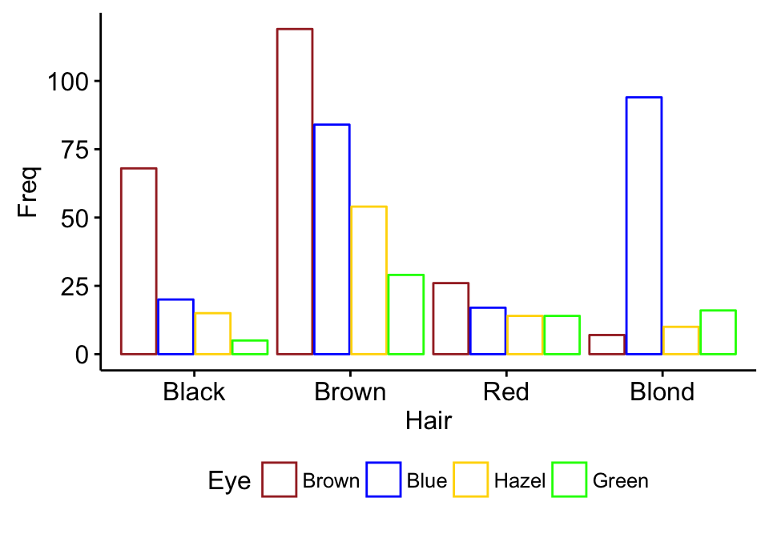

## 

## 

## 

## 

## **Multiway tables: More than two categorical variables**

* Hair and Eye color distributions by sex using **xtabs**():

**xtabs(~Hair + Eye + Sex, data = hair_eye_col)**

, , Sex = Male

Eye

Hair Brown Blue Hazel Green

Black 32 11 10 3

Brown 53 50 25 15

Red 10 10 7 7

Blond 3 30 5 8

, , Sex = Female

Eye

Hair Brown Blue Hazel Green

Black 36 9 5 2

Brown 66 34 29 14

Red 16 7 7 7

Blond 4 64 5 8

* You can also use the function **ftable**() [for flat contingency tables]. It returns a nice output compared to xtabs() when you have more than two variables:

**ftable(Sex + Hair ~ Eye, data = hair_eye_col)**

Sex Male Female

Hair Black Brown Red Blond Black Brown Red Blond

Eye

Brown 32 53 10 3 36 66 16 4

Blue 11 50 10 30 9 34 7 64

Hazel 10 25 7 5 5 29 7 5

Green 3 15 7 8 2 14 7 8

## 

## 

## **Compute table margins and relative frequency**

**Table margins** correspond to the sums of counts along rows or columns of the table. **Relative frequencies** express table entries as proportions of table margins (i.e., row or column totals).

The function **margin.table**() and **prop.table**() can be used to compute table margins and relative frequencies, respectively.

1. **Format of the functions**:

margin.table(x, margin = NULL)

prop.table(x, margin = NULL)

* **x**: table
* **margin**: index number (1 for rows and 2 for columns)

1. **compute table margins**:

Hair <- hair_eye_col$Hair

Eye <- hair_eye_col$Eye

# Hair/Eye color table

he.tbl <- table(Hair, Eye)

he.tbl

Eye

Hair Brown Blue Hazel Green

Black 68 20 15 5

Brown 119 84 54 29

Red 26 17 14 14

Blond 7 94 10 16

# Margin of rows

margin.table(he.tbl, 1)

Hair

Black Brown Red Blond

108 286 71 127

# Margin of columns

margin.table(he.tbl, 2)

Eye

Brown Blue Hazel Green

220 215 93 64

1. **Compute relative frequencies**:

# Frequencies relative to row total

prop.table(he.tbl, 1)

Eye

Hair Brown Blue Hazel Green

Black 0.62962963 0.18518519 0.13888889 0.04629630

Brown 0.41608392 0.29370629 0.18881119 0.10139860

Red 0.36619718 0.23943662 0.19718310 0.19718310

Blond 0.05511811 0.74015748 0.07874016 0.12598425

# Table of percentages

round(prop.table(he.tbl, 1), 2)*100

Eye

Hair Brown Blue Hazel Green

Black 63 19 14 5

Brown 42 29 19 10

Red 37 24 20 20

Blond 6 74 8 13

To express the frequencies relative to the grand total, use this:

he.tbl/sum(he.tbl)